PROJECT REPORT

IBM-Project-23327- 1659878210

**TITLE:**

# Skill / Job Recommender Application

**TEAM LEADER:**

MONISHA A

**TEAM MEMBER:**

* VAISHNAVI C
* JAYASHREE M
* MATHUMITHA R

**TEAM ID:**

PNT2022TMID23025

|  |  |
| --- | --- |
| **TABLE OF CONTENTS** | **PAGE NO** |
| 1. **INTRODUCTION**     1. Project Overview    2. Purpose | **1-2** |
| 1. **LITERATURE SURVEY**    1. Existing problem    2. References    3. Problem Statement Definition | **3-5** |
| 1. **IDEATION & PROPOSED SOLUTION**    1. Empathy Map Canvas    2. Ideation & Brainstorming    3. Proposed Solution    4. Problem Solution fit | **6-9** |
| 1. **REQUIREMENT ANALYSIS**    1. Functional requirement    2. Non-Functional requirements | **9-10** |
| 1. **PROJECT DESIGN**    1. Data Flow Diagrams    2. Solution & Technical Architecture    3. User Stories | **10-13** |
| 1. **PROJECT PLANNING & SCHEDULING**    1. Sprint Planning & Estimation    2. Sprint Delivery Schedule    3. Reports from JIRA | **14-15** |
| 1. **CODING & SOLUTIONING**    1. Feature 1    2. Feature 2 | **15-16** |
| 1. **TESTING**     1. Test Cases    2. User Acceptance Testing | **17** |
| 1. **RESULTS**    1. Performance Metrics | **18** |
| 1. **ADVANTAGES & DISADVANTAGES** | **19-20** |
| 1. **CONCLUSION** | **20** |
| **12.FUTURE SCOPE** | **21** |
| **13. APPENDIX** | **22** |

1. **INTRODUCTION**
   1. **Project Overview**

Job recommendation is an important task for the modern recruitment industry. An excellent job recommender system not only enables to recommend a higher paying job which is maximally aligned with the skill-set of the current job, but also suggests to acquire few additional skills which are required to assume the new position.

In this work, we created three types of information networks from the historical job data: (i) job transition network, (ii) job-skill network, and (iii) skill co-occurrence network. We provide a representation learning model which can utilize the information from all three networks to jointly learn the representation of the jobs and skills in the shared k-dimensional latent space.

In our experiments, we show that by jointly learning the representation for the jobs and skills, our model provides better recommendation for both jobs and skills. Additionally, we also show some case studies which validate our claim.

To develop an end-to-end web application capable of displaying the current job openings based on the user skillset.

The user and their information are stored in the Database.  An alert is sent when there is an opening based on the user skillset.

Users will interact with the chatbot and can get the recommendations based on their skills. We can use a job search API to get the current job openings in the market which will fetch the data directly from the webpage

**1.2 Purpose**

An excellent job recommender system not only enables to recommend a higher paying job which is maximally aligned with the skill-set of the current job, but also suggests to acquire few additional skills which are required to assume the new position.

To create a software that filters the job based on the skillset of the candidates who are seeking for the job.Then that filtered job is recommended for that candidates based on their skillset.

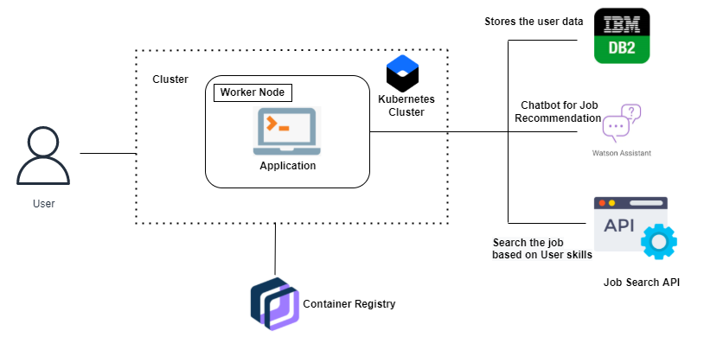

1. **LITERATURE SURVEY**
   1. **Existing problem**

“Job Recommendation based on Job Seeker Skills. Jorge ValverdeRebaza ,Ricardo Puma ,Paul Bustios ,Nathalia C. Silva. : First Workshop on Narrative Extraction From Text  co-located with 40th European Conference on Information Retrieval  March  2018”

In this ,when a candidate submits his/ her profile at a job seeker engine.

Their job recommendations are mostly suggested taking their academic qualification and work experience into considerations.

A survey of job recommender systems, Shaha Alotaibi ,International Jounal of Physical Sciences July 2012”

The recommender system technology aims to help users in finding items that match their personnel interests, it has a successful usage in e-commerce applications to deal with problems related to information overload efficiently.

This article will present a survey of e-recruiting process and existing recommendation approaches for building personalized recommender systems for candidates/job matching

A Research of Job Recommendation System Based on Collaborative Filtering: Cheng Yang,Yingya Zhang,Zhixiang Niu, 2014 Seventh International Symposium on Computational Intelligence and Design, December 2014”

It analyze the candidate’s resume and the companies’ recruitment guidelines.

To compare and come to a better conclusion upon finding the best suited candidates for the job

* 1. **References**

[1] Schafer J B, Frankowski D, Herlocker J, et al.

Collaborative _ltering recommender systems[M]//The

adaptive web. Springer Berlin Heidelberg, 2007: 291-324.

[2] Pazzani M J, Billsus D. Content-based recommendation

systems[M]//The adaptive web. Springer Berlin

Heidelberg, 2007:325-341.

[3] Sarwar B, Karypis G, Konstan J, et al. Item-based

collaborative _ltering recommendation

algorithms[C]//Proceedings of the 10th international conference on World Wide Web. ACM, 2001: 285-295.

[4] Nikolaos D. Almalis ,Prof. George A. Tsihrintzis ,

Nikolaos Karagianniset al."FoDRA - A New Content-Based

Job Recommendation Algorithm for Job Seeking and

Recruiting".

[5] Anika Gupta, Dr. Deepak Garg. "Applying Data Mining

Techniques in Job Recommender System for Considering

Candidate Job Preferences".

[6] Dunning T. Accurate methods for the statistics of

surprise and coincidence[J]. Computational linguistics,

1993, 19(1): 61-74.

[7] Emmanuel Malherbe , Mamadou Diaby , Mario Cataldi

et al. "Field Selection for Job Categorization and

Recommendation to Social Network Users". 2014

IEEE/ACM International Conference on Advances in Social

Networks Analysis and Mining (ASONAM 2014).

* 1. **Problem Statement Definition**

Having lots of skills but wondering which job will best suit you? Don’t need to worry! We have come up with a skill recommender solution through which the fresher or the skilled person can log in and find the jobs by using the search option or they can directly interact with the chatbot and get their dream job

To develop an end-to-end web application capable of displaying the current job openings based on the user skillset.  The user and their information are stored in the Database.  An alert is sent when there is an opening based on the user skillset. Users will interact with the chatbot and can get the recommendations based on their skills. We can use a job search API to get the current job openings in the market which will fetch the data directly from the webpage

1. **IDEATION & PROPOSED SOLUTION**
   1. **Empathy Map Canvas**

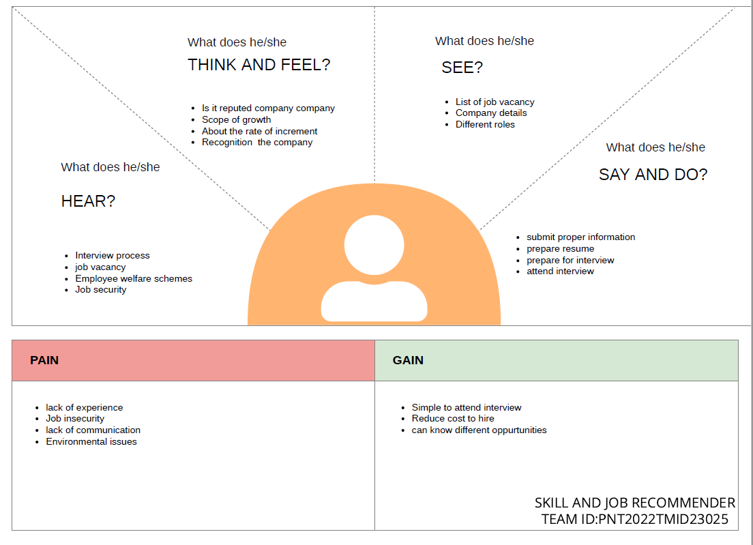

* 1. **Ideation & Brainstorming**

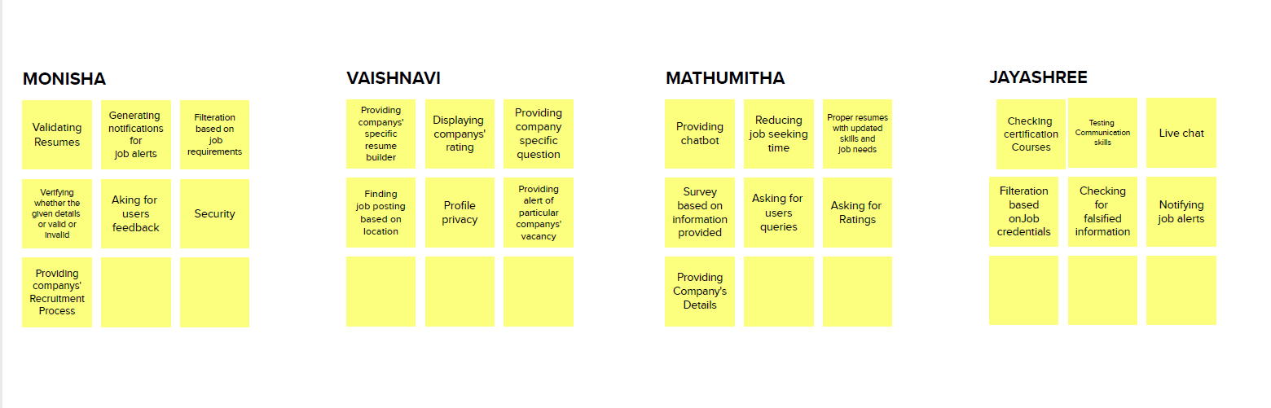

* 1. **Proposed Solution**

|  |  |  |  |  |  |  |
| --- | --- | --- | --- | --- | --- | --- |
| **S.No.** |  | | **Parameter** | |  | **Description** |
| 1. |  | | Problem Statement (Problem to be solved) | |  | Having lots of skills but wondering which job will best suit you? Don’t need to worry! We have come up with a skill recommender solution through which the fresher or the skilled person can log in and find the jobs by using the search option or they can directly interact with the chatbot and get their dream job.  To develop an end-to-end web application capable of displaying the current job openings based on the user skillset. The user and their information are stored in the Database. An alert is sent when there is an opening based on the user skillset. Users will interact with the chatbot and can get the recommendations based on their skills. We can use a job search API to get the current job openings in the market which will fetch the data  directly from  the webpage. |
|  | | |  | | |  |
| 2. | |  | | Idea / Solution description | The contributions of this work are threefold, we: i) made publicly available a new dataset formed by a set of job seekers profiles and a set of job vacancies collected from different job search engine sites ii) put forward the proposal of a framework for job recommendation based on professional skills of job seekers iii) carried out an evaluation to quantify | |
|  | |  | |  | empiíically the recommendation abilities of two state-of-the-art methods, considering different configurations, within the proposed fssramework. We thus present a general panorama of job recommendation task aiming to facilitate research and real- world application design regarding this important issue. | |
| 3. | |  | | Novelty / Uniqueness | The best position are suggested to any person according to her skills.While the position of known profiles are assumed | |

* 1. **Problem Solution fit**

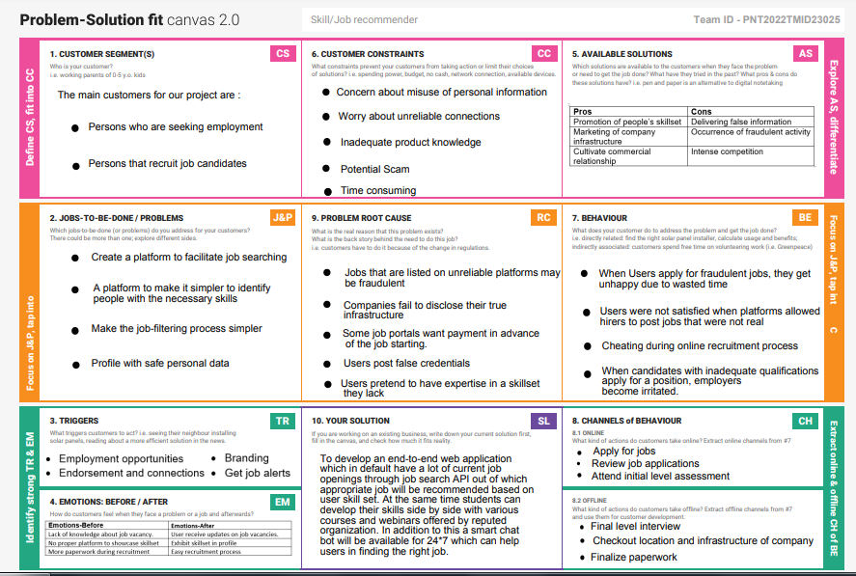

1. **REQUIREMENT ANALYSIS**
   1. **Functional requirement**

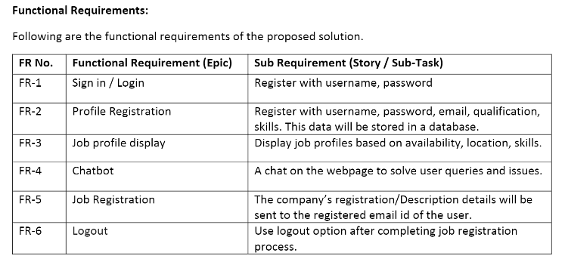

* 1. **Non-Functional requirements**

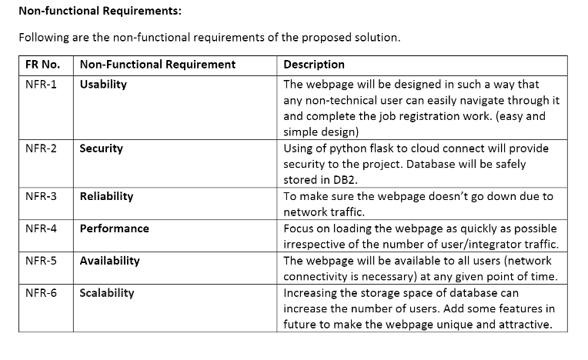

1. **PROJECT DESIGN**
   1. **Data Flow Diagrams**

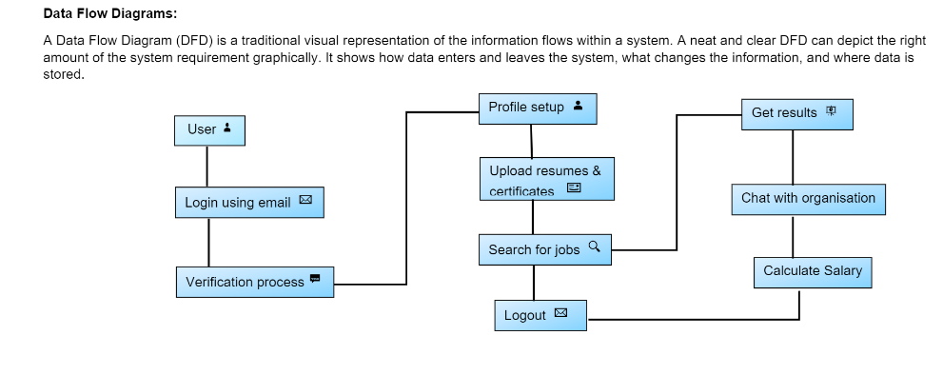

* 1. **Solution & Technical Architecture**

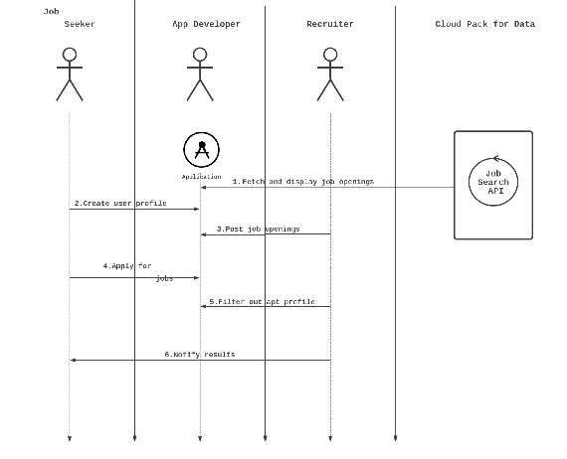



* 1. **User Stories**

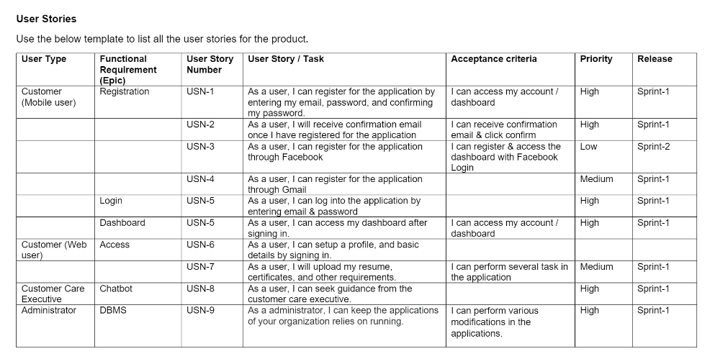

1. **PROJECT PLANNING & SCHEDULING**
   1. **Sprint Planning & Estimation**

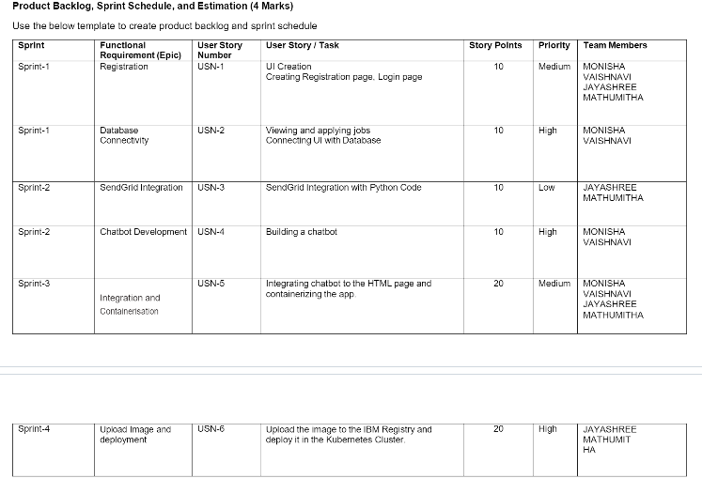

* 1. **Sprint Delivery Schedule**

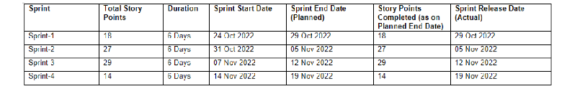

* 1. **Reports from JIRA**

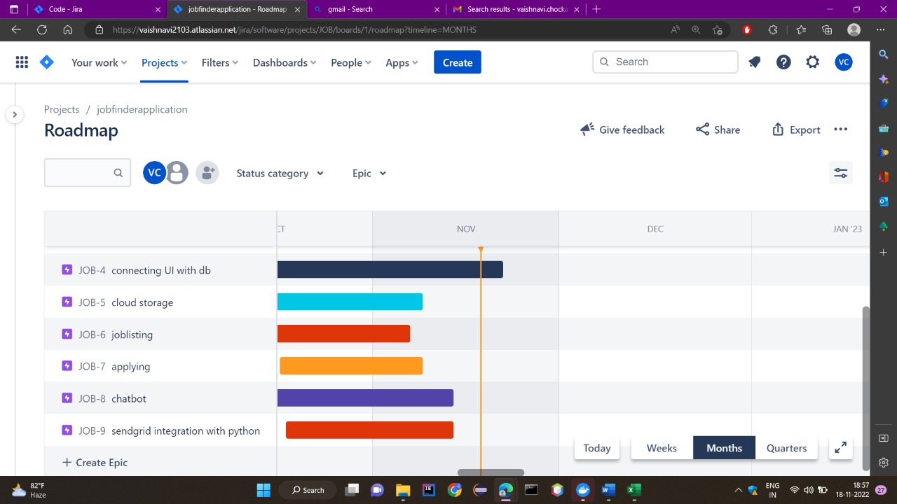

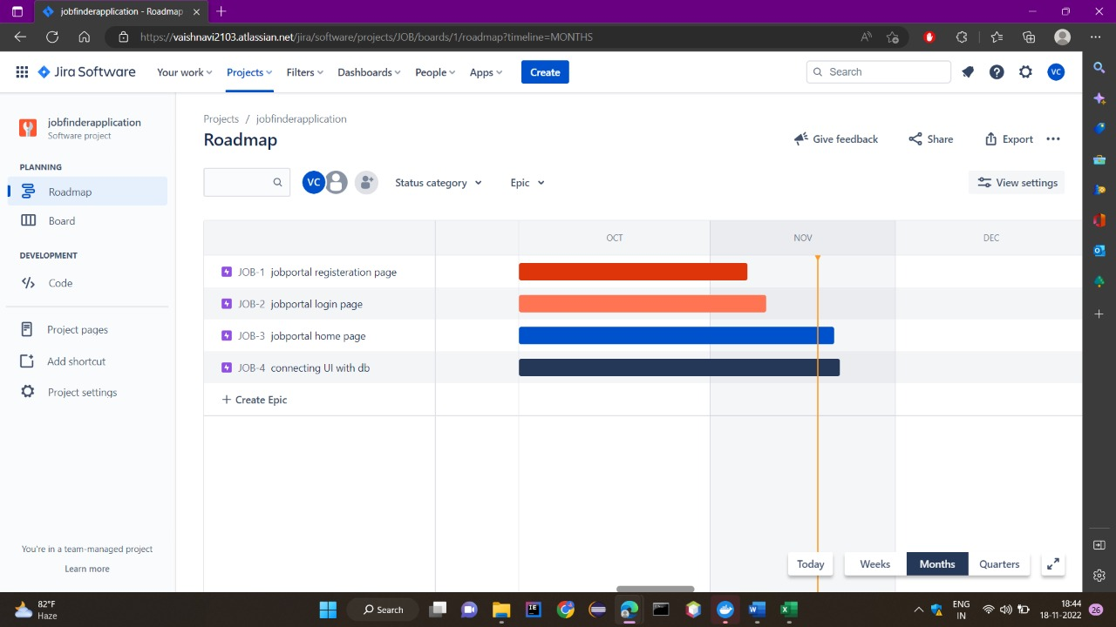

1. **CODING & SOLUTIONING** 
   1. **Feature 1**

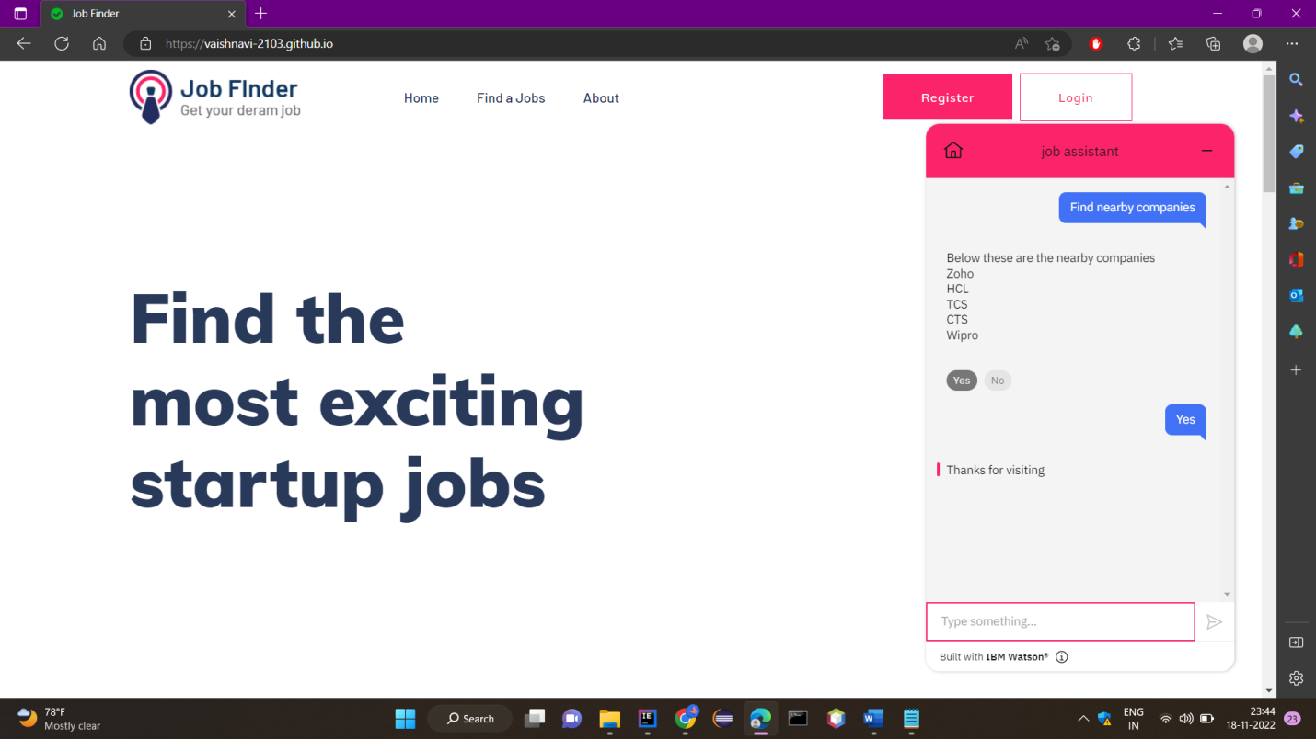

The software has an In-built “Chat Bot” which can help assist with ongoing queries and provide fast and effective solutions to user problems which may occur and also redirect to management attention if need be there any complications the customer service will be available 24*7 to assist in case of any controversial issues arise

* 1. **Feature 2**

In this project we have created the dashboard page to view the jobs available and to make ease to access the website

* They communicate information quickly.
* They display information clearly and efficiently.
* They show trends and changes in data over time.
* They are easily customizable.
* The most important widgets and data components are effectively presented in a limited space.

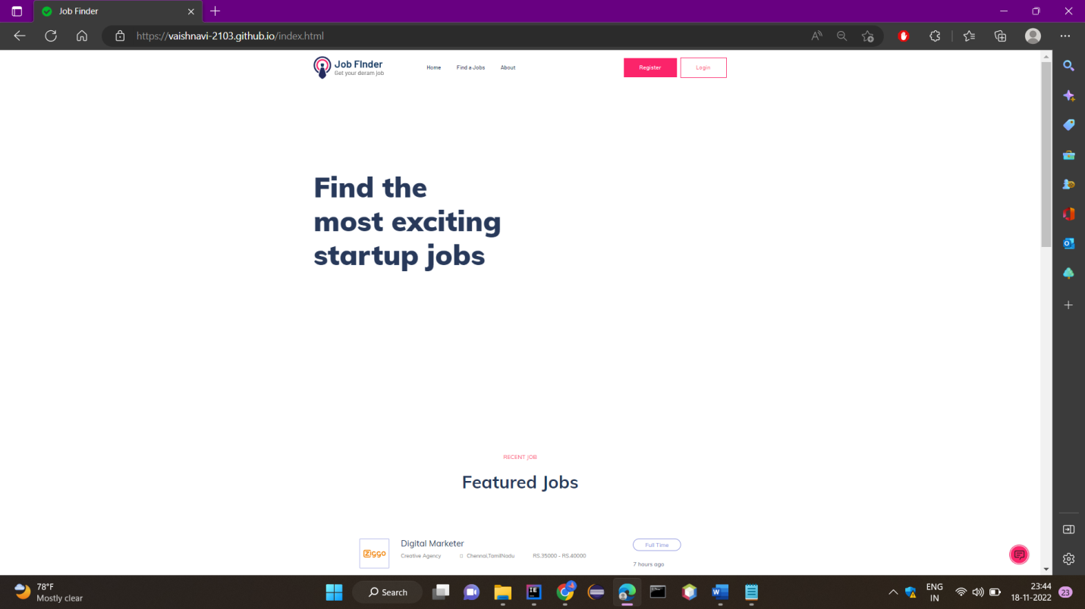

1. **TESTING** 
   1. **Test Cases**

Software testing is the process of evaluating and verifying that a software product or application does what it is supposed to do. The benefits of testing include preventing bugs, reducing development costs and improving performance.

**This Software is tested and evaluated successfully.**

* 1. **User Acceptance Testing**

Purpose of Document

The purpose of this document is to briefly explain the test coverage and open issues of the Inventory Management System project at the time of the release to User Acceptance Testing (UAT)

User Acceptance Testing is carried out in a separate testing environment. A change, an update, or a new feature is requested and developed. Unit and integration tests are run. All seems to be in order. But then, after it is released to the public, serious problems appear. Rework and retesting are not the most expensive consequences when that happens. Loss of reputation is.

1. **RESULTS**
   1. **Performance Metrics**

Based on the two types of user recommendations mentioned above, we analyze the

performance of all the techniques mentioned above. The resultant jobs recommended to each new user are then checked with the job that the user is originally in as per the test dataset. If the original user job is recommended in the model result, then the model appends 1 for yes else, it appends 0 for no.

This array of 0's and 1's thus received is then checked for accuracy by computing the count of 1's from the total user predictions

Among all the models made with the incorporation of different similarity metrics,

the cosine similarity based job recommendation system model outperformed rest of them

all. The metrics used to analyse the model performance are: accuracy, precision, recall and F1-score.This is because cosine considers the existence of duplicate terms while computing similarity.Also, computationally, cosine has low complexity and ease over handling spare data vectors since only non-zero dimensions are considered.

Upon analyzing the result table we observe that the short-comings of some similarity measures upon recommending top 5 and highest-score based job recommendations as even upon achieving high . similarity scores is due to the fact that users are seen to have different jobs than the ones recommended by the models, thus resulting in 6–10% error rates.

1. **ADVANTAGES**

* The model doesn't need any data about other users, since the recommendations are specific to this user.
* This makes it easier to scale to a large number of users.
* The model can capture the specific interests of a user, and can recommend niche items that very few other users are interested in.

**DISADVANTAGES**

* Since the feature representation of the items are hand-engineered to some extent,this technique requires a lot of domain knowledge. Therefore, the model can only be as good as the hand-engineered features.
* The model can only make recommendations based on existing interests of the user.
* In other words, the model has limited ability to expand on the users' existing interests

1. **CONCLUSION**

In this project, Content-Based Filtering and Collaborative Filtering of recommendations

have been compared. Additionally, an aggregation plus recommender system has been devised.

Content-Based Filtering recommends the results based on matching the personal preferences

of the user with the given document whereas collaborative filtering recommends based on the

preferences of fellow users. On evaluating both of these methods, it was concluded that a

hybrid system of both of these overcomes the limitations of both of them and increases the

efficiency of ranking. Problems of cold start, sparse database, scalability, and lack of

trend recommendation have been eliminated. The proposal is to design a Job Recommender

system that prioritizes quality over quantity. While there are websites and job listing portals

already recommending jobs to job seekers based on their profiles, this research on aggregate

quality recommendations has been achieved by crawling selectively, overcoming the limitations. A fully functioning user interface was developed to combine everything together to give the user a seamless experience**.**

1. **FUTURE SCOPE**

Future works in the case of Personalized Job Recommendation Systems are the utilization of the user-preferred location to get job recommendations based on jobs in organizations established in nearby areas. This can be done by extracting the latitudes and longitudes of the user-preferred location and computing the euclidean distances between the latitudes and longitudes of the organization location.

This filters out other jobs that fall far from the user-preferred location and gives a more accurate job recommender

As part of the future work, we plan to usefeatures of similar candidates and jobs

insequence information. As of now,recommendation using similar candidates an jobs forms part of non-machine learning basedrecommendations and the initial result seempromising. Finally, it would be interesting toextend our methodology to other recommendersystems

1. **APPENDIX**

**Source Code**

|  |
| --- |
|  |
|  | <!DOCtype html>  <html class="no-js" lang="zxx"> |
|  | <head> |
|  | <meta charset="utf-8"> |
|  | <meta http-equiv="x-ua-compatible" content="ie=edge"> |
|  | <title>Job Finder</title> |
|  | <meta name="description" content=""> |
|  | <meta name="viewport" content="width=device-width, initial-scale=1"> |
|  | <link rel="manifest" href="site.webmanifest"> |
|  | <link rel="shortcut icon" type="image/x-icon" href="http://s3.jp-tok.cloud-object-storage.appdomain.cloud/jobportalwebsite/assets/img/favicon.ico"> |
|  |  |
|  | <link rel="stylesheet" href="http://s3.jp-tok.cloud-object-storage.appdomain.cloud/jobportalwebsite/assets/css/bootstrap.min.css"> |
|  | <link rel="stylesheet" href="http://s3.jp-tok.cloud-object-storage.appdomain.cloud/jobportalwebsite/assets/css/owl.carousel.min.css"> |
|  | <link rel="stylesheet" href="http://s3.jp-tok.cloud-object-storage.appdomain.cloud/jobportalwebsite/assets/css/flaticon.css"> |
|  | <link rel="stylesheet" href="http://s3.jp-tok.cloud-object-storage.appdomain.cloud/jobportalwebsite/assets/css/price_rangs.css"> |
|  | <link rel="stylesheet" href="http://s3.jp-tok.cloud-object-storage.appdomain.cloud/jobportalwebsite/assets/css/slicknav.css"> |
|  | <link rel="stylesheet" href="http://s3.jp-tok.cloud-object-storage.appdomain.cloud/jobportalwebsite/assets/css/animate.min.css"> |
|  | <link rel="stylesheet" href="http://s3.jp-tok.cloud-object-storage.appdomain.cloud/jobportalwebsite/assets/css/magnific-popup.css"> |
|  | <link rel="stylesheet" href="http://s3.jp-tok.cloud-object-storage.appdomain.cloud/jobportalwebsite/assets/css/fontawesome-all.min.css"> |
|  | <link rel="stylesheet" href="http://s3.jp-tok.cloud-object-storage.appdomain.cloud/jobportalwebsite/assets/css/themify-icons.css"> |
|  | <link rel="stylesheet" href="http://s3.jp-tok.cloud-object-storage.appdomain.cloud/jobportalwebsite/assets/css/slick.css"> |
|  | <link rel="stylesheet" href="http://s3.jp-tok.cloud-object-storage.appdomain.cloud/jobportalwebsite/assets/css/nice-select.css"> |
|  | <link rel="stylesheet" href="http://s3.jp-tok.cloud-object-storage.appdomain.cloud/jobportalwebsite/assets/css/style.css"> |
|  |  |
|  | <body> |
|  |  |
|  | <header> |
|  | <!-- Header Start --> |
|  | <div class="header-area header-transparrent"> |
|  | <div class="headder-top header-sticky"> |
|  | <div class="container"> |
|  | <div class="row align-items-center"> |
|  | <div class="col-lg-3 col-md-2"> |
|  | <!-- Logo --> |
|  | <div class="logo"> |
|  | <a href="index.html"><img src="http://s3.jp-tok.cloud-object-storage.appdomain.cloud/jobportalwebsite/assets/img/logo/logo.png" alt=""></a> |
|  | </div> |
|  | </div> |
|  | <div class="col-lg-9 col-md-9"> |
|  | <div class="menu-wrapper"> |
|  | <!-- Main-menu --> |
|  | <div class="main-menu"> |
|  | <nav class="d-none d-lg-block"> |
|  | <ul id="navigation"> |
|  | <li><a href="/index">Home</a></li> |
|  | <li><a href="/job_listing">Find a Jobs </a></li> |
|  | <li><a href="/about">About</a></li> |
|  |  |
|  | </ul> |
|  | </nav> |
|  | </div> |
|  | <!-- Header-btn --> |
|  | <div class="header-btn d-none f-right d-lg-block"> |
|  | <a href="/registeration" class="btn head-btn1">Register</a> |
|  | <a href="/login" class="btn head-btn2">Login</a> |
|  | </div> |
|  | </div> |
|  | </div> |
|  | <!-- Mobile Menu --> |
|  | <div class="col-12"> |
|  | <div class="mobile_menu d-block d-lg-none"></div> |
|  | </div> |
|  | </div> |
|  | </div> |
|  | </div> |
|  | </div> |
|  | <!-- Header End --> |
|  | </header> |
|  | <main> |
|  |  |
|  | <!-- slider Area Start--> |
|  | <div class="slider-area "> |
|  | <!-- Mobile Menu --> |
|  | <div class="slider-active"> |
|  | <div class="single-slider slider-height d-flex align-items-center" data-background="http://s3.jp-tok.cloud-object-storage.appdomain.cloud/jobportalwebsite/assets/img/hero/h1_hero.jpg"> |
|  | <div class="container"> |
|  | <div class="row"> |
|  | <div class="col-xl-6 col-lg-9 col-md-10"> |
|  | <div class="hero__caption"> |
|  | <h1>Find the most exciting startup jobs</h1> |
|  | </div> |
|  | </div> |
|  | </div> |
|  |  |
|  |  |
|  |  |
|  | </div> |
|  | </div> |
|  | </div> |
|  | </div> |
|  | <!-- slider Area End--> |
|  | <!-- Featured_job_start --> |
|  | <section class="featured-job-area feature-padding"> |
|  | <div class="container"> |
|  | <!-- Section Tittle --> |
|  | <div class="row"> |
|  | <div class="col-lg-12"> |
|  | <div class="section-tittle text-center"> |
|  | <span>Recent Job</span> |
|  | <h2>Featured Jobs</h2> |
|  | </div> |
|  | </div> |
|  | </div> |
|  | <div class="row justify-content-center"> |
|  | <div class="col-xl-10"> |
|  | <!-- single-job-content --> |
|  | <div class="single-job-items mb-30"> |
|  | <div class="job-items"> |
|  | <div class="company-img"> |
|  | <a href="#"><img src="http://s3.jp-tok.cloud-object-storage.appdomain.cloud/jobportalwebsite/assets/img/icon/job-list1.png" alt="img"></a> |
|  | </div> |
|  | <div class="job-tittle job-tittle2"> |
|  | <a href="#"> |
|  | <h4>Digital Marketer</h4> |
|  | </a> |
|  | <ul> |
|  | <li>Creative Agency</li> |
|  | <li><i class="fas fa-map-marker-alt"></i>Chennai,TamilNadu</li> |
|  | <li>RS.35000 - RS.40000</li> |
|  | </ul> |
|  | </div> |
|  | </div> |
|  | <div class="items-link items-link2 f-right"> |
|  | <a href="/job_details">Full Time</a> |
|  | <span>7 hours ago</span> |
|  | </div> |
|  | </div> |
|  | <!-- single-job-content --> |
|  | <div class="single-job-items mb-30"> |
|  | <div class="job-items"> |
|  | <div class="company-img"> |
|  | <a href="#"><img src="http://s3.jp-tok.cloud-object-storage.appdomain.cloud/jobportalwebsite/assets/img/icon/job-list2.png" alt="img"></a> |
|  | </div> |
|  | <div class="job-tittle job-tittle2"> |
|  | <a href="#"> |
|  | <h4>Back End Developer</h4> |
|  | </a> |
|  | <ul> |
|  | <li>Mentee Chain</li> |
|  | <li><i class="fas fa-map-marker-alt"></i>Chennai,TamilNadu</li> |
|  | <li>RS.41500 - RS.72000</li> |
|  | </ul> |
|  | </div> |
|  | </div> |
|  | <div class="items-link items-link2 f-right"> |
|  | <a href="/job_details">Full Time</a> |
|  | <span>5 hours ago</span> |
|  | </div> |
|  | </div> |
|  | <!-- single-job-content --> |
|  | <div class="single-job-items mb-30"> |
|  | <div class="job-items"> |
|  | <div class="company-img"> |
|  | <a href="#"><img src="http://s3.jp-tok.cloud-object-storage.appdomain.cloud/jobportalwebsite/assets/img/icon/job-list3.png" alt=""></a> |
|  | </div> |
|  | <div class="job-tittle job-tittle2"> |
|  | <a href="#"> |
|  | <h4>SQL Developer</h4> |
|  | </a> |
|  | <ul> |
|  | <li>Sutherland</li> |
|  | <li><i class="fas fa-map-marker-alt"></i>Chennai,TamilNadu</li> |
|  | <li>RS.82500 - RS.44000</li> |
|  | </ul> |
|  | </div> |
|  | </div> |
|  | <div class="items-link items-link2 f-right"> |
|  | <a href="/job_details">Full Time</a> |
|  | <span>2 hours ago</span> |
|  | </div> |
|  | </div> |
|  | <!-- single-job-content --> |
|  | <div class="single-job-items mb-30"> |
|  | <div class="job-items"> |
|  | <div class="company-img"> |
|  | <a href="#"><img src="http://s3.jp-tok.cloud-object-storage.appdomain.cloud/jobportalwebsite/assets/img/icon/job-list4.png" alt=""></a> |
|  | </div> |
|  | <div class="job-tittle job-tittle2"> |
|  | <a href="#"> |
|  | <h4>TIBCO Developer</h4> |
|  | </a> |
|  | <ul> |
|  | <li>Infosys</li> |
|  | <li><i class="fas fa-map-marker-alt"></i>Chennai,TamilNadu</li> |
|  | <li>RS.53500 - RS.40000</li> |
|  | </ul> |
|  | </div> |
|  | </div> |
|  | <div class="items-link items-link2 f-right"> |
|  | <a href="/job_details">Full Time</a> |
|  | <span>1 hours ago</span> |
|  | </div> |
|  | </div> |
|  | <!-- single-job-content --> |
|  | <div class="single-job-items mb-30"> |
|  | <div class="job-items"> |
|  | <div class="company-img"> |
|  | <a href="#"><img src="http://s3.jp-tok.cloud-object-storage.appdomain.cloud/jobportalwebsite/assets/img/icon/job-list1.png" alt=""></a> |
|  | </div> |
|  | <div class="job-tittle job-tittle2"> |
|  | <a href="#"> |
|  | <h4>Hadoop Developer</h4> |
|  | </a> |
|  | <ul> |
|  | <li>Capgemini</li> |
|  | <li><i class="fas fa-map-marker-alt"></i>Chennai,TamilNadu</li> |
|  | <li>RS.33500 - RS.24000</li> |
|  | </ul> |
|  | </div> |
|  | </div> |
|  | <div class="items-link items-link2 f-right"> |
|  | <a href="/job_details">Full Time</a> |
|  | <span>3 hours ago</span> |
|  | </div> |
|  | </div> |
|  | <!-- single-job-content --> |
|  | <div class="single-job-items mb-30"> |
|  | <div class="job-items"> |
|  | <div class="company-img"> |
|  | <a href="#"><img src="http://s3.jp-tok.cloud-object-storage.appdomain.cloud/jobportalwebsite/assets/img/icon/job-list3.png" alt=""></a> |
|  | </div> |
|  | <div class="job-tittle job-tittle2"> |
|  | <a href="#"> |
|  | <h4>Full stack Developer</h4> |
|  | </a> |
|  | <ul> |
|  | <li>VCW Limited</li> |
|  | <li><i class="fas fa-map-marker-alt"></i>Chennai,TamilNadu</li> |
|  | <li>RS.45500 - RS.24000</li> |
|  | </ul> |
|  | </div> |
|  | </div> |
|  | <div class="items-link items-link2 f-right"> |
|  | <a href="/job_details">Full Time</a> |
|  | <span>4 hours ago</span> |
|  | </div> |
|  | </div> |
|  | <!-- single-job-content --> |
|  | <div class="single-job-items mb-30"> |
|  | <div class="job-items"> |
|  | <div class="company-img"> |
|  | <a href="#"><img src="http://s3.jp-tok.cloud-object-storage.appdomain.cloud/jobportalwebsite/assets/img/icon/job-list4.png" alt=""></a> |
|  | </div> |
|  | <div class="job-tittle job-tittle2"> |
|  | <a href="#"> |
|  | <h4>Senior FinOps Engineer</h4> |
|  | </a> |
|  | <ul> |
|  | <li>WPP</li> |
|  | <li><i class="fas fa-map-marker-alt"></i>Chennai,TamilNadu</li> |
|  | <li>RS.33500 - RS54000</li> |
|  | </ul> |
|  | </div> |
|  | </div> |
|  | <div class="items-link items-link2 f-right"> |
|  | <a href="/job_details">Full Time</a> |
|  | <span>6 hours ago</span> |
|  | </div> |
|  | </div> |
|  | </div> |
|  | </section> |
|  | <!-- Featured_job_end --> |
|  | <!-- How Apply Process Start--> |
|  | <div class="apply-process-area apply-bg pt-150 pb-150" data-background="http://s3.jp-tok.cloud-object-storage.appdomain.cloud/jobportalwebsite/assets/img/gallery/how-applybg.png"> |
|  | <div class="container"> |
|  | <!-- Section Tittle --> |
|  | <div class="row"> |
|  | <div class="col-lg-12"> |
|  | <div class="section-tittle white-text text-center"> |
|  | <span>Apply process</span> |
|  | <h2> How it works</h2> |
|  | </div> |
|  | </div> |
|  | </div> |
|  | <!-- Apply Process Caption --> |
|  | <div class="row"> |
|  | <div class="col-lg-4 col-md-6"> |
|  | <div class="single-process text-center mb-30"> |
|  | <div class="process-ion"> |
|  | <span class="flaticon-search"></span> |
|  | </div> |
|  | <div class="process-cap"> |
|  | <h5>1. Search a job</h5> |
|  | <p></p> |
|  | </div> |
|  | </div> |
|  | </div> |
|  | <div class="col-lg-4 col-md-6"> |
|  | <div class="single-process text-center mb-30"> |
|  | <div class="process-ion"> |
|  | <span class="flaticon-curriculum-vitae"></span> |
|  | </div> |
|  | <div class="process-cap"> |
|  | <h5>2. Apply for job</h5> |
|  | <p></p> |
|  | </div> |
|  | </div> |
|  | </div> |
|  | <div class="col-lg-4 col-md-6"> |
|  | <div class="single-process text-center mb-30"> |
|  | <div class="process-ion"> |
|  | <span class="flaticon-tour"></span> |
|  | </div> |
|  | <div class="process-cap"> |
|  | <h5>3. Get your job</h5> |
|  | <p></p> |
|  | </div> |
|  | </div> |
|  | </div> |
|  | </div> |
|  | </div> |
|  | </div> |
|  | <!-- How Apply Process End--> |
|  |  |
|  | </main> |
|  | <footer> |
|  | <!-- Footer Start--> |
|  | <div class="footer-area footer-bg footer-padding"> |
|  | <div class="container"> |
|  | <div class="row d-flex justify-content-between"> |
|  | <div class="col-xl-3 col-lg-3 col-md-4 col-sm-6"> |
|  | <div class="single-footer-caption mb-50"> |
|  | <div class="single-footer-caption mb-30"> |
|  | <div class="footer-tittle"> |
|  | <h4>About Us</h4> |
|  | <div class="footer-pera"> |
|  | <p> Connect the world’s professionals to make them more productive and successful.</p> |
|  |  |
|  |  |
|  | </div> |
|  | </div> |
|  | </div> |
|  |  |
|  | </div> |
|  | </div> |
|  | <div class="col-xl-3 col-lg-3 col-md-4 col-sm-5"> |
|  | <div class="single-footer-caption mb-50"> |
|  | <div class="footer-tittle"> |
|  | <h4>Contact Info</h4> |
|  | <ul> |
|  | <li> |
|  | <p>Address :<br> |
|  | 2, jobfinds ltd, |
|  | <br> |
|  | Anna Nagar, |
|  | <br>madurai</p> |
|  |  |
|  | </li> |
|  | <li><a href="#">Phone : +99999 99999</a></li> |
|  | <li><a href="#">Email : info@jobfinder.com</a></li> |
|  | </ul> |
|  | </div> |
|  |  |
|  | </div> |
|  | </div> |
|  | <!-- footer-bottom area --> |
|  | <div class="footer-bottom-area footer-bg"> |
|  | <div class="container"> |
|  | <div class="footer-border"> |
|  | <div class="row d-flex justify-content-between align-items-center"> |
|  | <div class="col-xl-10 col-lg-10 "> |
|  | <div class="footer-copy-right"> |
|  | <p> |
|  | Copyright &copy;<script>document.write(new Date().getFullYear());</script> All rights reserved |
|  | </p> |
|  | </div> |
|  | </div> |
|  |  |
|  | </div> |
|  | </div> |
|  | </div> |
|  | </div> |
|  | </div> |
|  |  |
|  | </div> |
|  | </div> |
|  | <!-- Footer End--> |
|  | </footer> |
|  | <!-- JS here --> |
|  |  |
|  | <!-- All JS Custom Plugins Link Here here --> |
|  | <script src="http://s3.jp-tok.cloud-object-storage.appdomain.cloud/jobportalwebsite/assets/js/vendor/modernizr-3.5.0.min.js"></script> |
|  | <!-- Jquery, Popper, Bootstrap --> |
|  | <script src="http://s3.jp-tok.cloud-object-storage.appdomain.cloud/jobportalwebsite/assets/js/vendor/jquery-1.12.4.min.js"></script> |
|  | <script src="http://s3.jp-tok.cloud-object-storage.appdomain.cloud/jobportalwebsite/assets/js/popper.min.js"></script> |
|  | <script src="http://s3.jp-tok.cloud-object-storage.appdomain.cloud/jobportalwebsite/assets/js/bootstrap.min.js"></script> |
|  | <!-- Jquery Mobile Menu --> |
|  | <script src="http://s3.jp-tok.cloud-object-storage.appdomain.cloud/jobportalwebsite/assets/js/jquery.slicknav.min.js"></script> |
|  |  |
|  | <!-- Jquery Slick , Owl-Carousel Plugins --> |
|  | <script src="http://s3.jp-tok.cloud-object-storage.appdomain.cloud/jobportalwebsite/assets/js/owl.carousel.min.js"></script> |
|  | <script src="http://s3.jp-tok.cloud-object-storage.appdomain.cloud/jobportalwebsite/assets/js/slick.min.js"></script> |
|  | <script src="http://s3.jp-tok.cloud-object-storage.appdomain.cloud/jobportalwebsite/assets/js/price_rangs.js"></script> |
|  | <!-- One Page, Animated-HeadLin --> |
|  | <script src="http://s3.jp-tok.cloud-object-storage.appdomain.cloud/jobportalwebsite/assets/js/wow.min.js"></script> |
|  | <script src="http://s3.jp-tok.cloud-object-storage.appdomain.cloud/jobportalwebsite/assets/js/animated.headline.js"></script> |
|  | <script src="http://s3.jp-tok.cloud-object-storage.appdomain.cloud/jobportalwebsite/assets/js/jquery.magnific-popup.js"></script> |
|  |  |
|  | <!-- Scrollup, nice-select, sticky --> |
|  | <script src="http://s3.jp-tok.cloud-object-storage.appdomain.cloud/jobportalwebsite/assets/js/jquery.scrollUp.min.js"></script> |
|  | <script src="http://s3.jp-tok.cloud-object-storage.appdomain.cloud/jobportalwebsite/assets/js/jquery.nice-select.min.js"></script> |
|  | <script src="./assets/js/jquery.sticky.js"></script> |
|  |  |
|  | <!-- contact js --> |
|  | <script src="http://s3.jp-tok.cloud-object-storage.appdomain.cloud/jobportalwebsite/assets/js/contact.js"></script> |
|  | <script src="http://s3.jp-tok.cloud-object-storage.appdomain.cloud/jobportalwebsite/assets/js/jquery.form.js"></script> |
|  | <script src="http://s3.jp-tok.cloud-object-storage.appdomain.cloud/jobportalwebsite/assets/js/jquery.validate.min.js"></script> |
|  | <script src="http://s3.jp-tok.cloud-object-storage.appdomain.cloud/jobportalwebsite/assets/js/mail-script.js"></script> |
|  | <script src="http://s3.jp-tok.cloud-object-storage.appdomain.cloud/jobportalwebsite/assets/js/jquery.ajaxchimp.min.js"></script> |
|  |  |
|  | <!-- Jquery Plugins, main Jquery --> |
|  | <script src="http://s3.jp-tok.cloud-object-storage.appdomain.cloud/jobportalwebsite/assets/js/plugins.js"></script> |
|  | <script src="http://s3.jp-tok.cloud-object-storage.appdomain.cloud/jobportalwebsite/assets/js/main.js"></script> |
|  |  |
|  |  |
|  |  |
|  | <script> |
|  | window.watsonAssistantChatOptions = { |
|  | integrationID: "65c01ed6-9fc1-4883-979a-3676279ebe44", // The ID of this integration. |
|  | region: "us-south", // The region your integration is hosted in. |
|  | serviceInstanceID: "8fcd017f-a192-420a-aafc-18cb0330efca", // The ID of your service instance. |
|  | onLoad: function(instance) { instance.render(); } |
|  | }; |
|  | setTimeout(function(){ |
|  | const t=document.createElement('script'); |
|  | t.src="https://web-chat.global.assistant.watson.appdomain.cloud/versions/" + (window.watsonAssistantChatOptions.clientVersion || 'latest') + "/WatsonAssistantChatEntry.js"; |
|  | document.head.appendChild(t); |
|  | }); |
|  | </script> |
|  |  |
|  | </body> |
|  | </html> |

**GitHub Link:**

**<https://github.com/IBM-EPBL/IBM-Project-23327-1659878210>**

**Project Demo Link:**

<https://vaishnavi-2103.github.io/>

<https://drive.google.com/file/d/1RYCmuE3hcgtkdGFkqq9-PZKwrWmkzvmw/view?usp=sharing>